**GUSTAV KLIMT**

[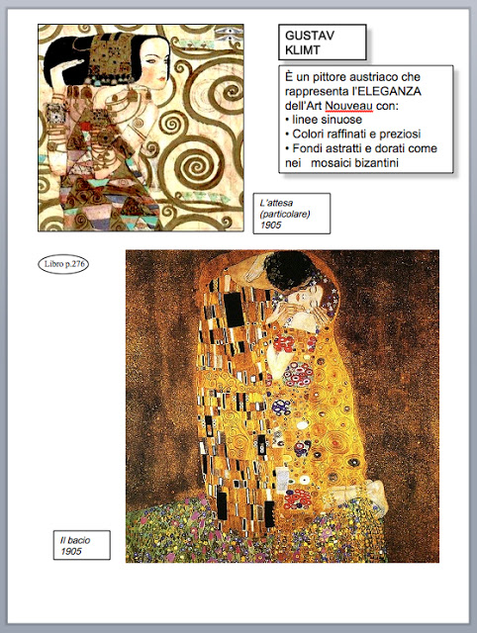](http://3.bp.blogspot.com/_Iwz2bmfC9H8/TU_Vp6qLuDI/AAAAAAAAAYg/o4xRJEuHrmU/s1600/art+nouveau2.jpg)